- EDA of forest fire dataset
Count and percentage by fire-cause category (Verification&EDA/fire_cause_breakdown.sql):
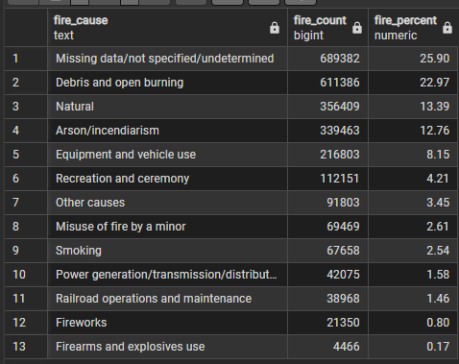
Fire Size Distribution (Verification&EDA/fire_size_distribution.sql):
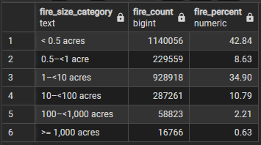

- Verification of forest fire filtering:

Counts the total number of fires after filtering (Verification&EDA/total_fires_after filter.sql):
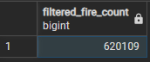
Breakdown of Fire Causes after Filtering (Verification&EDA/breakdown_after_filtering.sql):
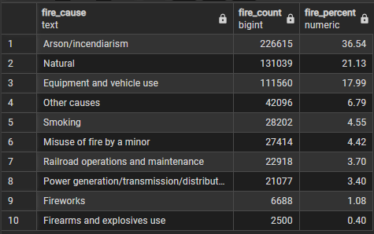
- Verification of initial grid:
Count of total cells (Verification&EDA/count_cells.sql)
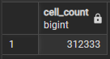

Verify cell dimensions (Verification&EDAcell_dimensions.sql)
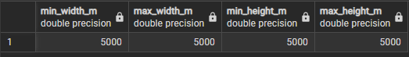

Check reference system used by geometry (Verification&EDA/ check_grid_reference_system.sql)
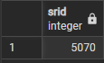

- Verification or fire to grid assignment (Verification&EDA/fires_assigned.sql):
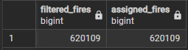

Check top 10 locations with most fires to see if they make sense (Verification&EDA/top_10_locations.sql):
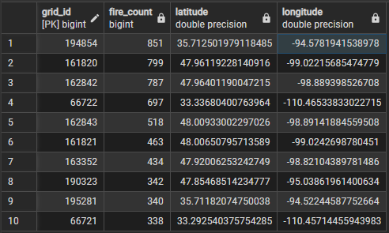
1. N4740 Road, Bell, Adair County, OK, United States of America
2. Fort Totten District, ND 58335, United States of America
3. Saint Michael District, Benson County, ND 58370, United States of America
4. Powerline Road, San Carlos, AZ 85542, United States of America
5. Bureau of Indian Affairs Road 4, Saint Michael District, Benson County, ND 58370, United States of America
6. Bureau of Indian Affairs Road 27, Fort Totten District, ND 58335, United States of America
7. Bia 21, Tokio, Wood Lake District, ND 58379, United States of America
8. Doc Road, Beltrami County, MN 56671, United States of America
9. unnamed road, Bell, Adair County, OK, United States of America
10. Coolidge Dam Road, Peridot, Gila County, AZ 85542, United States of America

Check dates covered (Verification&EDA/check_dates_covered_by_fires.sql)
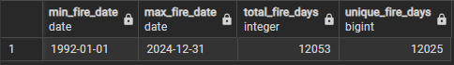

- Assign each cell to the closest weather station with complete data

Get station distance percentiles by year (Verification&EDA/station_distance.sql):
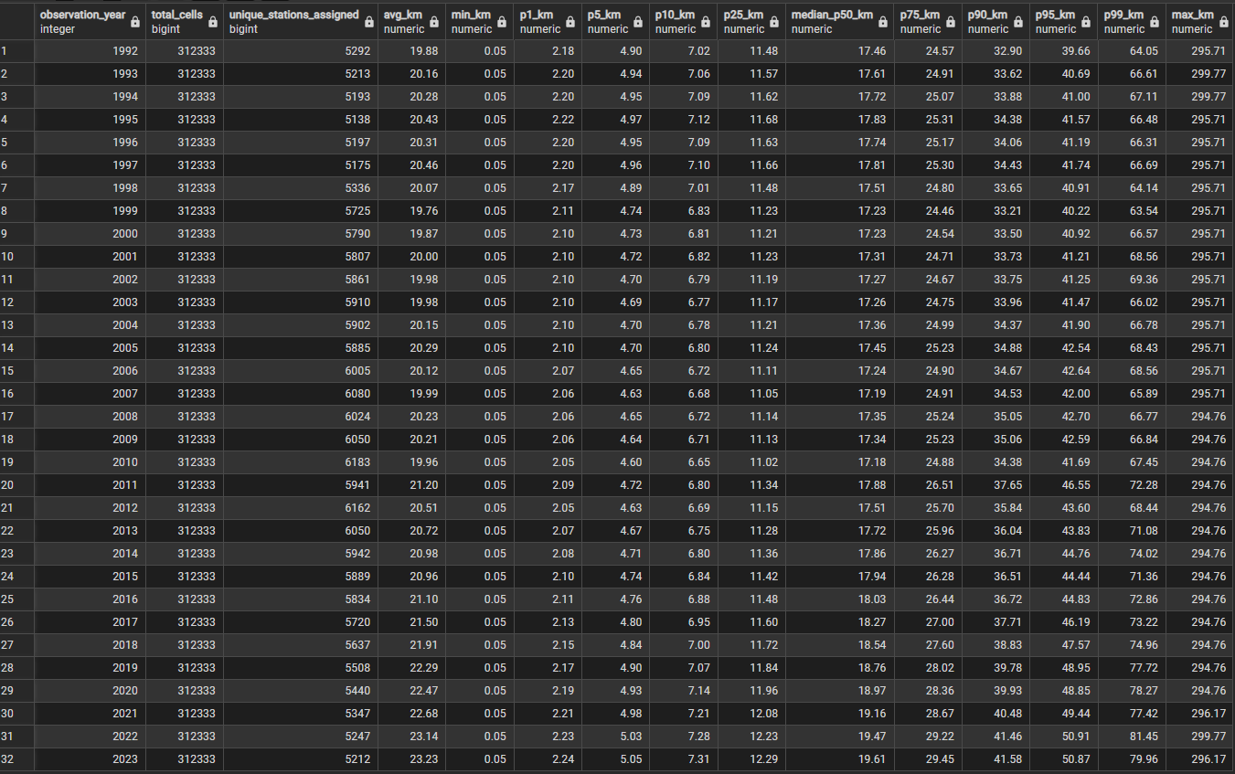

Overall

Weather data completeness check (Verification&EDA/ check_weather_completeness.sql):
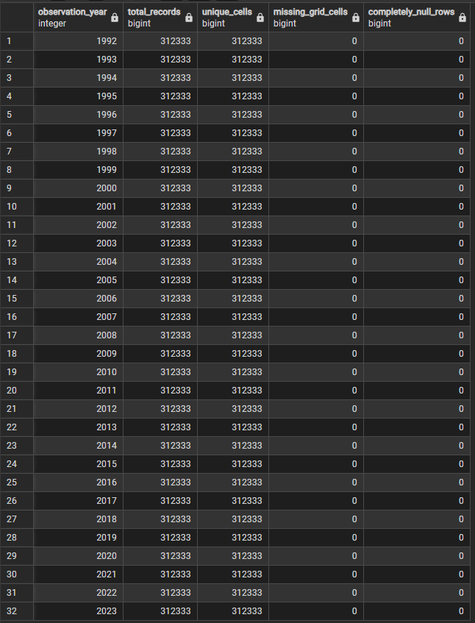

- Load NCLD landcover data and convert to percentages for the 5km x 5km format
Check data completeness (Verification&EDA/landcover_completeness.sql):
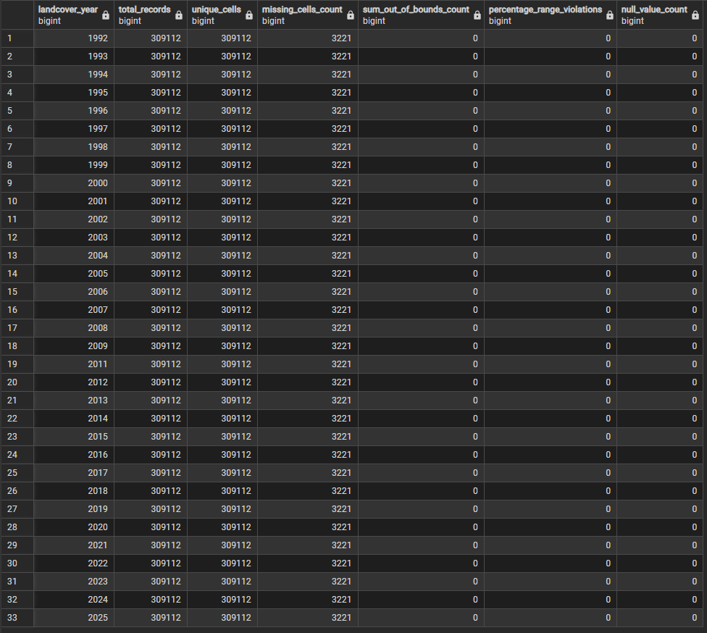

- Overall summary and row count comparison (Verification&EDA/drought_summary.sql):
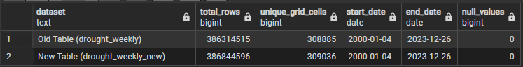

Check rows, cells, and dates (Verification&EDA/final_drought_check.sql)


